PAPER TITLE ( 12pt Times New Roman, Bold, Justified, CAP)

Correspondence Author *, Co-author (11pt Times New Roman, Bold, Justified)

* Department, Collage, Country (11pt Times New Roman, Justified)
Abstract An abstract of no more than 250 words (10pt Times New Roman, Justified).
Keywords 2-5 Keywords are required (10pt Times New Roman, Justified).
Introduction/ Background
All content should be written in English and should be in Single column.
- Page type will be A4 with ner margin, word spacing should be 1.
- No space will be added before or after paragraph.
- The references should be represented as large brackets e.g [2] in the text.
Materials and Methods
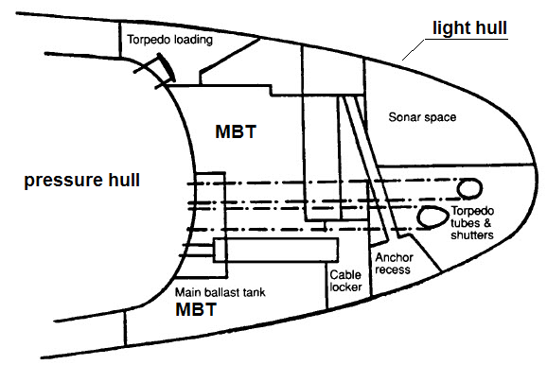
Figure 1: Typical bow arrangement
Results & Discussion
Table 1: Specification of Models in stage
Nf | Rt | Aw | Cd*1000 | V/(Cd*10) | Cv*100
1 | 1944 | 11.16 | 3.484 | 59.99 | 2.38
1.15 | 1820 | 11.79 | 3.087 | 73.20 | 2.11
Conclusion
Acknowledgment
References
- Moonesun, M., Javadi, M., Charmdooz, P., & Mikhailovich, K. U. (2013). Evaluation of submarine model test in towing tank and comparison with CFD and experimental formulas for fully submerged resistance. Indian Journal of Geo-Marine Sciences, 42(8), 1049-1056.
- Moonesun, M. (2014). Introduction of Iranian hydrodynamic series of submarines (IHSS). Journal of Taiwan society of naval architecture and marine engineering, 33(3), 155-162.

